MongoDB Lab 2

1. a) Create Database company and create a Collection with name employee and

b) Insert 10 documents to the collection with fields empid, name, salary and designation.

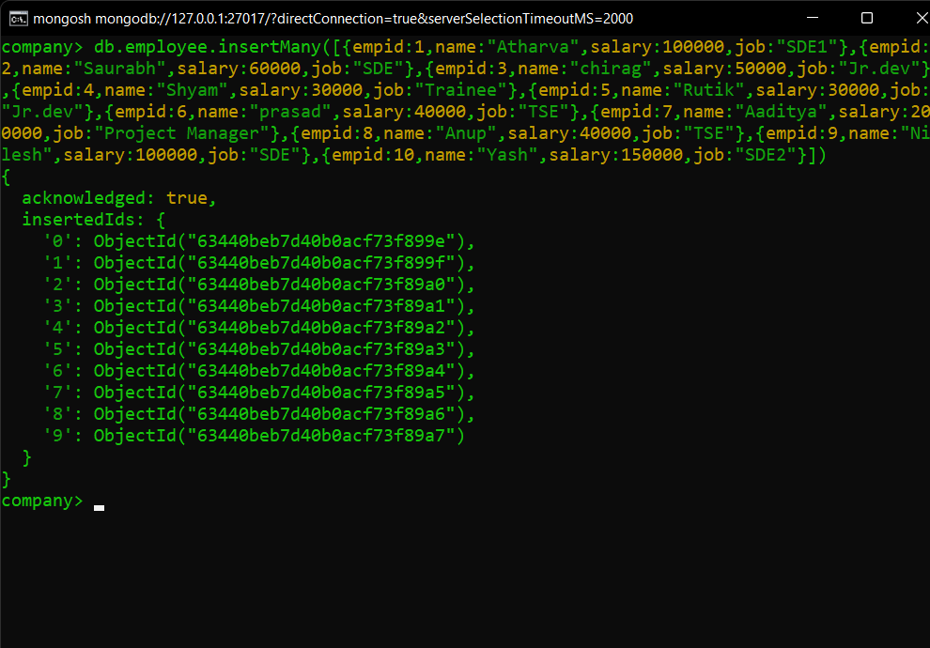

c) Display all the employee details.

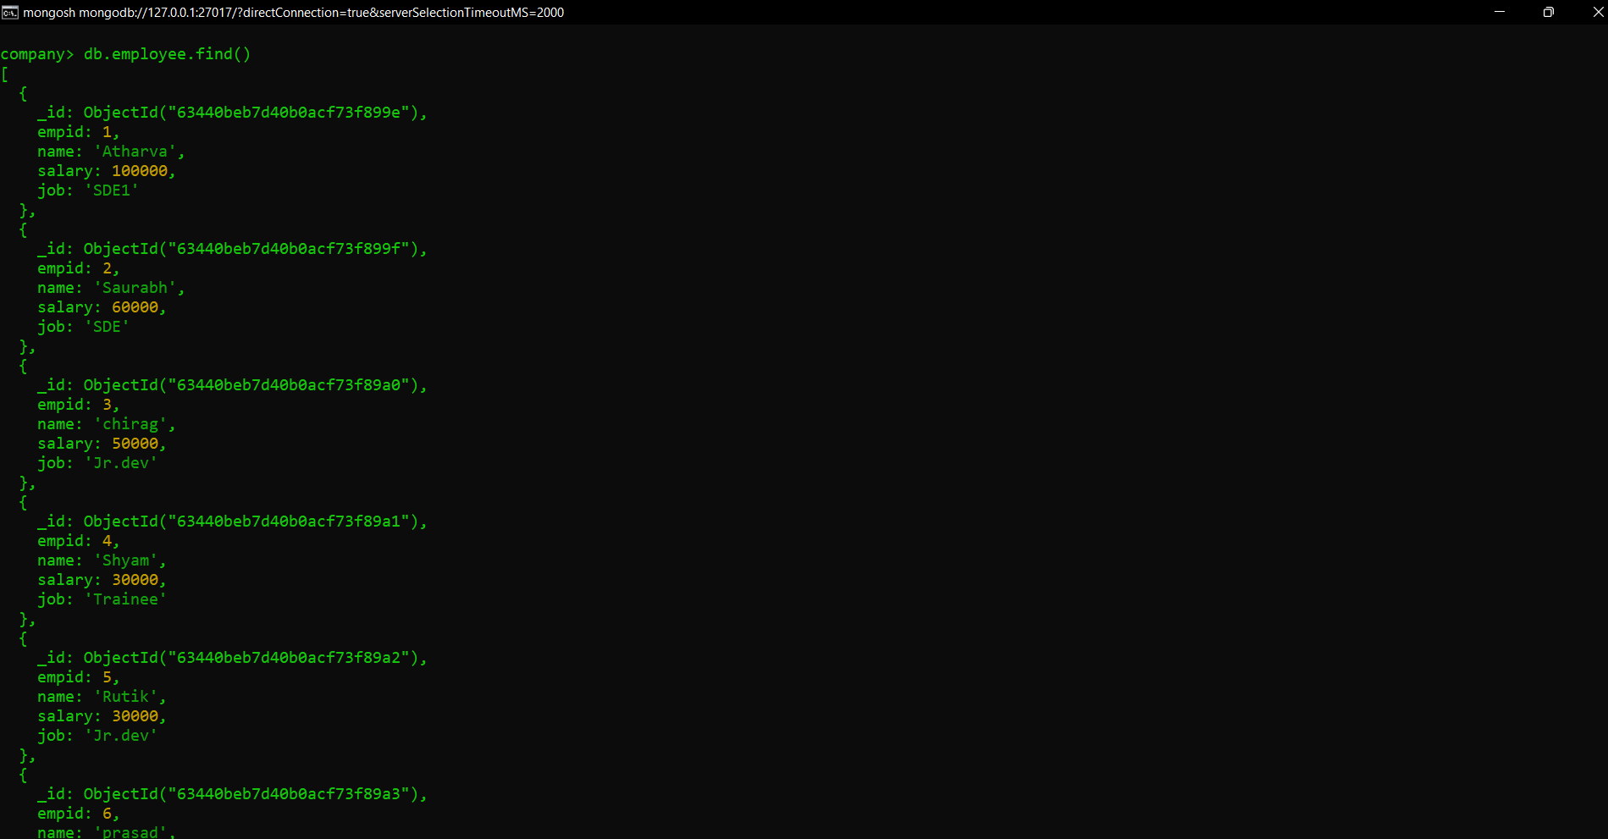

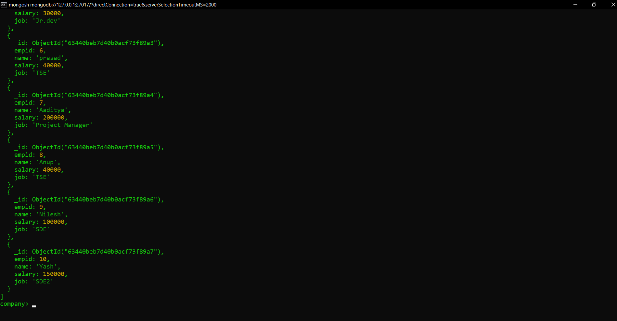

d) Display only empid,name and salary (don’t display _id and designation)

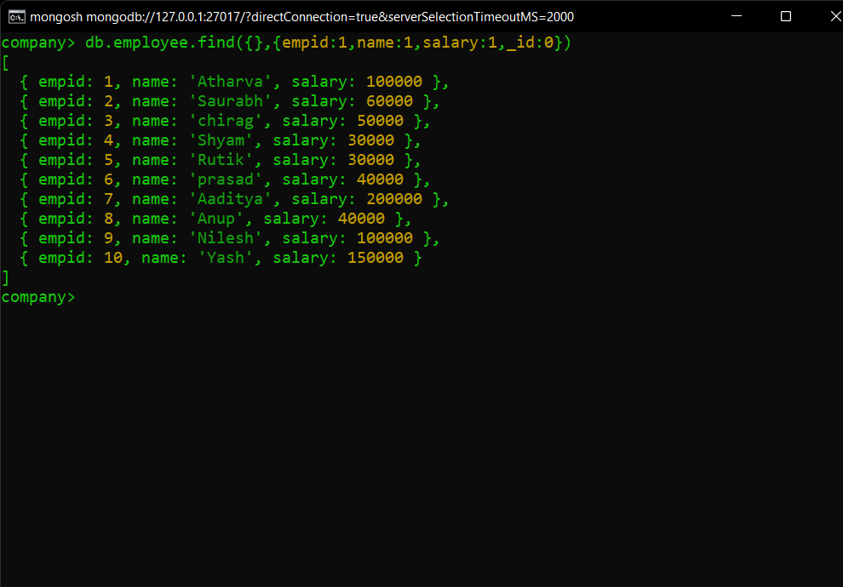

e) Update salary of a particular employee.

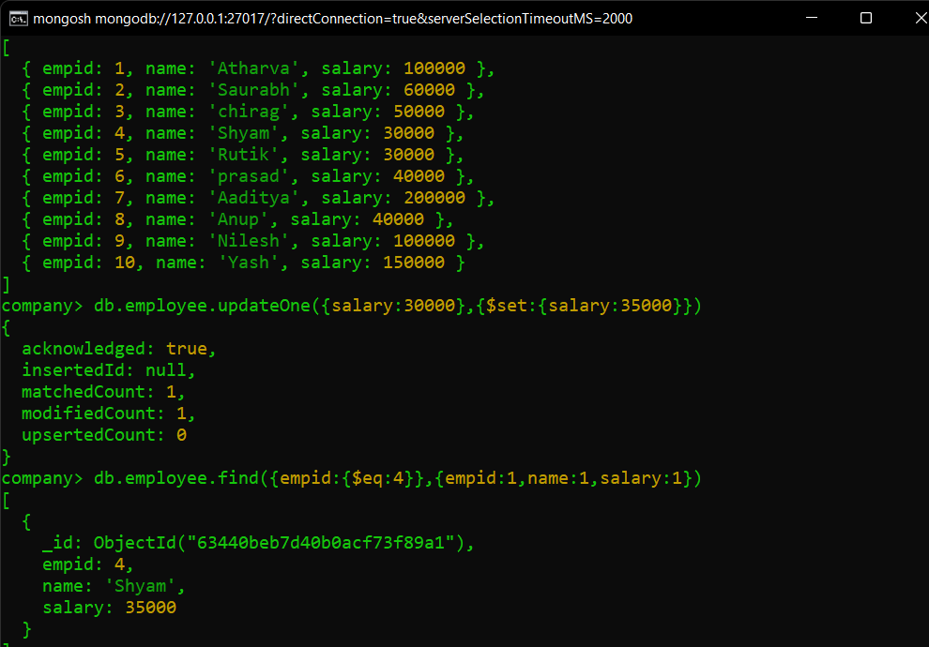

e) Add one more field department to the collection.

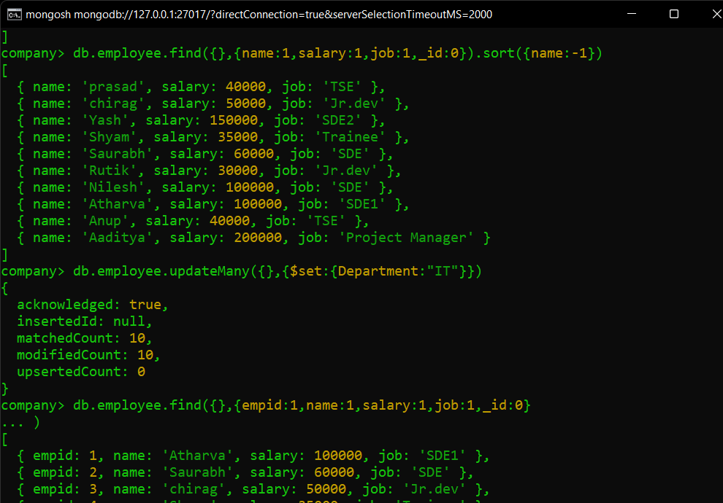

f) Display the fields name, salary,designation for all the documents in the descending order of name field

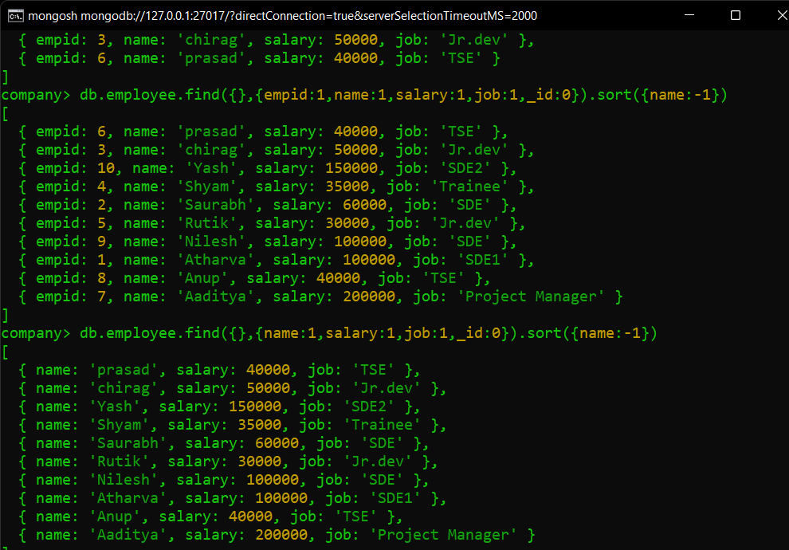g) Display the first 3 employee details whose salary is greater than a specified value.

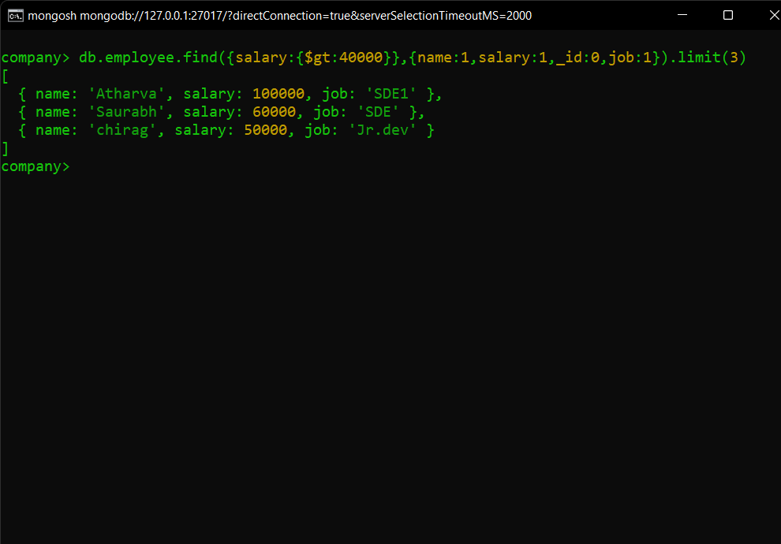

h) delete some documents having salary less than some values.

